

**EXPERIMENT NO:05**

**Aim:** Sketch State Transition Diagram for our Project.

**Tools:** IBM Rational Rose

**Theory**: A state machine is any device that stores the status of an object at a given time and can change status or cause other actions based on the input it receives. States refer to the different combinations of information that an object can hold, not how the object behaves. In order to understand the different states of an object, you might want to visualize all of the possible states and show how an object gets to each state, and you can do so with a UML state diagram.

Each state diagram typically begins with a dark circle that indicates the initial state and ends with a bordered circle that denotes the final state. However, despite having clear start and end points, state diagrams are not necessarily the best tool for capturing an overall progression of events. Rather, they illustrate specific kinds of behaviour—in particular, shifts from one state to another.State diagrams mainly depict states and transitions. States are represented with rectangles with rounded corners that are labelled with the name of the state. Transitions are marked with arrows that flow from one state to another, showing how the states change. Below, you can see both these elements at work in a basic diagram for student life.

* **State diagram applications**

Like most UML diagrams, state diagrams have several uses. The main applications are as follows:

* Depicting event-driven objects in a reactive system.
* Illustrating use case scenarios in a business context.
* Describing how an object moves through various states within its lifetime.
* Showing the overall behaviour of a state machine or the behaviour of a related set of state machines.
* **State diagram symbols and components**
* **Composite state**

A state that has substates nested into it. See the university state diagram example below. “Enrollment” is the composite state in this example because it encompasses various substates in the enrolment process.

* **Choice pseudo state**

A diamond symbol that indicates a dynamic condition with branched potential results.



* **Event**

An instance that triggers a transition, labeled above the applicable transition arrow. In this case, “classes end” is the event that triggers the end of the “Being taught” state and the beginning of the “Final exams” state.

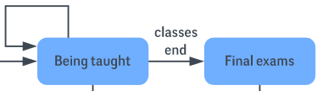

* **Exit point**

The point at which an object escapes the composite state or state machine, denoted by a circle with an X through it. The exit point is typically used if the process is not completed but has to be escaped for some error or other issue.

State Diagram Symbols - Exit Point

* **First state**

A marker for the first state in the process, shown by a dark circle with a transition arrow.



* **Guard**

A Boolean condition that allows or stops a transition, written above the transition arrow.

* **State**

A rectangle with rounded corners that indicates the current nature of an object.

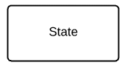

* **Substate**

A state contained within a composite state's region. In the university state machine diagram found below, “Open for enrollment” is a substate in the larger “Enrollment” composite state.

* **Terminator**

A circle with a dot in it that indicates that a process is terminated.



* **Transition**

An arrow running from one state to another that indicates a changing state.

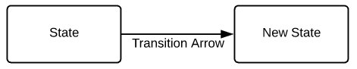

* **Transitional behaviour**

A behaviour that results when a state transitions, written above the transition arrow.

* **Trigger**

A type of message that actively moves an object from state to state, written above the transition arrow. In this example, “Issue with reservation” is the trigger that would send the person to the airport travel agency instead of the next step in the process.

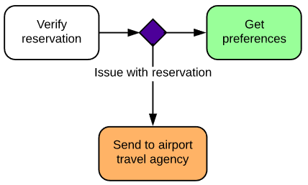

* **State Transition Diagram for Bank Management System**

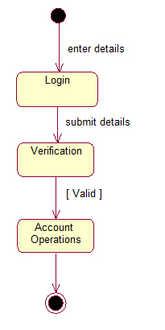

**Conclusion:** A state transition diagram is used to represent a finite state machine. These are used to model objects which have a finite number of possible states and whose interaction with the outside world can be described by its state changes in response to a finite number of events. Thus, we have successfully understood and sketch the state transition diagram for our project.

For Faculty Use

|  |  |  |  |  |
| --- | --- | --- | --- | --- |
| **CorrectionParameters** | **FormativeAssessment[40%]** | **Timely completionofPractical[40%]** | **Attendance /LearningAttitude[20%]** |  |
| **MarksObtained** |  |  |  |